Title of Your Work (4pt Times New Roman)
Member’s Names (11pt Times New Roman)
Affiliation, Country, e-mail (10.5pt Times New Roman)

Abstract
Here you write the overview of your product. The length of the abstract should be 200-300 words. In the beginning of the abstract, the subject of the paper should be stated clearly, together with its scope and objectives. Then, the methods, equipment, results and conclusions in the paper should be stated concisely in a sufficiently logical manner. (10pt Times New Roman)
Note: This is a sample template for proceeding. Please follow the format within two pages.
Example: With increasing demands for efficient logistics, an intelligent logistic car is created which is aimed at high-efficiency factory transportation to satisfy the requirements of safe, economical and efficient goods transportation. The mechanism behind can be divided into hardware and software aspect: in terms of software, Cartographer Algorithm(used for mapping), YOLO V3 Algorithm(used for object identification in visual function) and AMCL Algorithm(used for navigation) are applied to realize four functional modules; in the aspect of hardware, single-line lidar(used for navigation), infrared sensor and depth-camera(used for automatic following) are adopted to fulfill different requirements of functions.
Background & Purpose
Here you explain the background, purpose and subject of your product. (10pt Times New Roman)
Example: Currently, the price of labor force is considerably high especially in developed countries, which makes the outlay of labor force account for large parts in logistics industry expanse and poses increasing burden on industry development. Consequently, creating an effective logistics car which is able to guarantee operating efficiency is compulsory. Specifically, the logistics car ought to be intelligent enough to carry out different tasks, efficient enough to create profits.
Concept & Idea
Here you explain the design and function of your product in detail. (10pt Times New Roman)
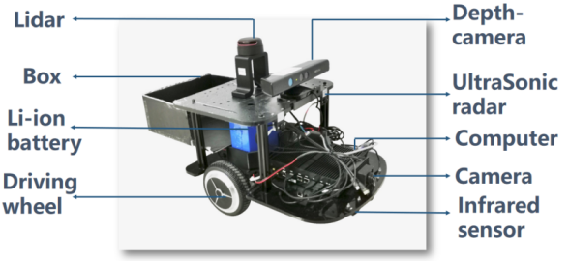
Example: The overall structure of the design is showed in the Fig.1. The car is designed on an idealized platform and series of accurate sensors is installed to fulfill multiple functions. Specifically, lidar (a sensor that can transmit laser to all directions) is able to effectively detect nearby environments. Depth-camera is aimed to detect accurately in short distance and identify some key characteristics of obstacle like person. Infrared sensor is utilized to detects relatively short distance (no more than 1m) in quick response and maintain safety distance from obstacle. Camera is used to capture front images by visual function.The sensors coordinate with each other to complete the task.
Fig.1 Example of drawing figure. (9pt, Times New Roman)
Design & Functions
Here you explain the design and function of your product in detail. (10pt Times New Roman)
Example:A factory-simulated environment is established to launch the simulation of real-world factory transportation, which shows the process of autonomous transportation by this car. The simulated process is divided into several parts which display functional modules.
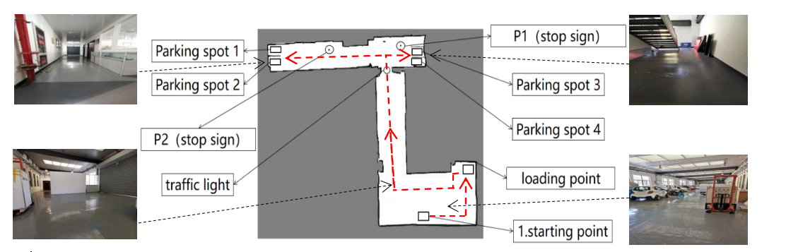
Function 1(Mapping): The intelligent car utilizes lidar to transform the real scene into a 2-D map. This 2-D map(Fig. 2) is the transformation of simulated scene by using Cartographer Algorithm.
Fig. 2 The simulated 2-D map
Function 2(Visual function): The car utilizes Convolutional Neural Networks for environment detection. Four kinds of signs are selected in the simulated scene, such as traffic light and parking sign. Then the car is trained with the YOLO V3 Algorithm to equip it with visual capacity, laying the foundation of automatic following and navigation.
Fig. 3 The depth information from depth-camera
Function 3(Automatic Following): The car utilizes depth-camera and infrared sensor to identify and follow the worker to loading point, in which process the car realizes collision avoidance and speed adjustment automatically. After recognizing people successfully by adopting human-body recognizing algorithm in depth-camera(Fig. 3), the car starts to follow automatically.
Problems & Future work
Here you explain the problems which are still remained and the future work to complete your product. (10pt Times New Roman)
Example: Four functional modules have been integrated in the logistics car with employing numbers of fashioned algorithms. Some of the algorithms have the potential to be polished, leading to better performance. What’s more, testing environment also has the potential to be improved by adding more complexity, by which more faults could be found to optimize the design.

